1. Create repository

2. Create files and push to repository

3. Create another branch

4. Add files to new branch(staging) and push back to git

5. Create PR and merge with main branch

6. Create development branch and create 3files -> add 3files -> do commit -> revert 1file out of 3

7. Create uat branch and create 3files -> add 3files -> do commit -> do push -> revert 1file out of 3

**1. create repository**

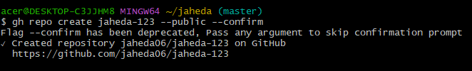

**2. create files and push to repository**

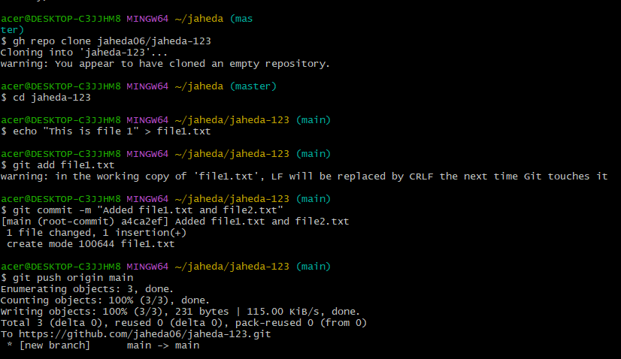

**3. Create another branch**

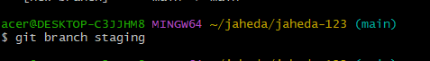

**4. Add files to new branch(staging) and push back to git**

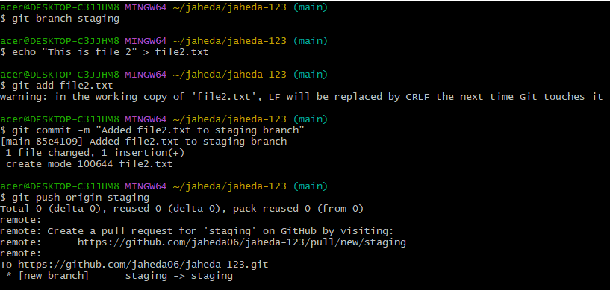

5. Create PR and merge with main branch

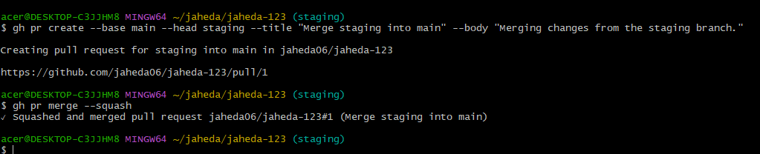

**6. Create development branch and create 3files -> add 3files -> do commit -> revert 1file out of 3**

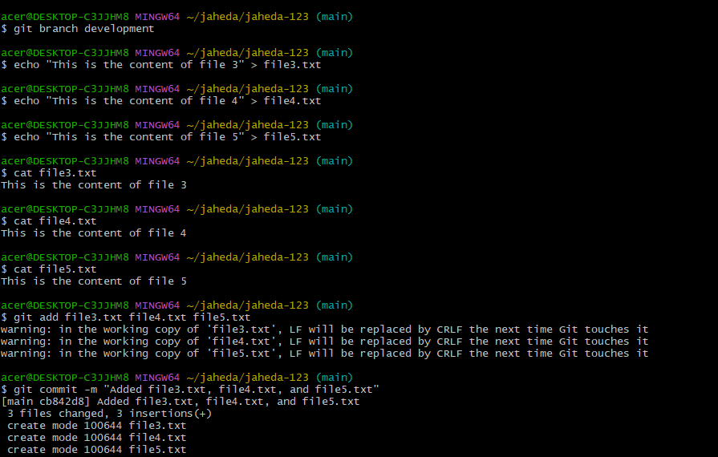

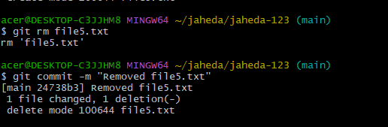

**7. Create uat branch and create 3files -> add 3files -> do commit -> do push -> revert 1file out of 3**

